“SECONDARY METABOLITES”
The seeds, plants, fruits and vegetables besides contribute nutrients; contain a number of substances which can be protective to the body, called SECONDARY METABOLITES.
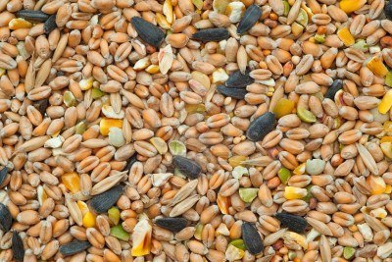
Secondary metabolites are components that affect one or more functions of body in form specified and positive, being beneficial to long term for our health.
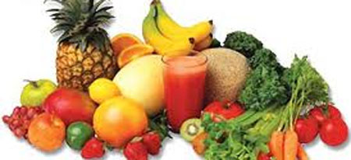
There are a variety of secondary metabolites, which are grouped according to their function and structural characteristics, TERPENES, PHENOLS AND THIOLS.
TERPENES
ACTIVE SUBSTANCE | FUNCTION | FOOD SOURCE
Carotenoids | Important for the immune system, for the development and maintenance of epithelial tissue, and care of bronchi and lungs. | Carrots, spinach, chard, parsley, red paprika, celery, citrus, peach and melon.
Phytosterols | Reduce cholesterol levels and therefore cardiovascular diseases. | Broccoli, cauliflower, cucumber, soy products, tomatoes, eggplant, peppers, beans grains, fruits, nuts, cereals and vegetable oil.
Capsaicin | Qualities decongestants, favors the brain's production of endorphins, effects analgesic and anti-inflammatory. | Chili and pepper.
Saponins | Effect protective against  stomach cancer and  intestine. | Garlic, onions, licorice roots and ginseng.

PHENOLS
ACTIVE SUBSTANCE | FUNCTION | FOOD SOURCE
Isoflavones | Decrease the risk of cardiovascular disease. | Carrots, broccoli, cauliflower, cucumber, tomato, pepper, eggplant, soy products, parsley, tofu, chickpeas, string beans, onions, peanuts, apples, cherries, citrus fruits and green tea.
Lignans | Prevention of breast cancer, endometrial and prostate. | Pumpkin, sesame, rye, soy beans, wheat grains, barley, oats, garlic, asparagus, broccoli and carrot.
Flavonoids | Defense against cancer. | Celery, onions, cauliflower, broccoli, parsley, soybeans, tomatoes, eggplant, thyme, soy, tofu, grapefruit, orange, cherry, apple and tea.
Anthocyanins | Prevention against degeneration in cells of organs in humans. | Purple cabbage and onion abode. Skin of fruits like apple, pear, grape, blackberry, plum flowers like and Jamaica.
Catechins | Properties, Anti-arthritic, anti-inflammatory, anti-ulcer and immunostimulants. | Cherry and green tea.
Taninos | Are used as anti-diarrheal, in the treatment of varicose veins, hemorrhoids and small wounds. | Apples and raspberries.

THIOLS
ACTIVE SUBSTANCE | FUNCTION | FOOD SOURCE
Organosulfur compounds | Prevent activation of  carcinogens. | Cauliflower, lettuce, chard, broccoli, garlic, onions, scallions, sprouts, radish, mustard and citrus fruits.

